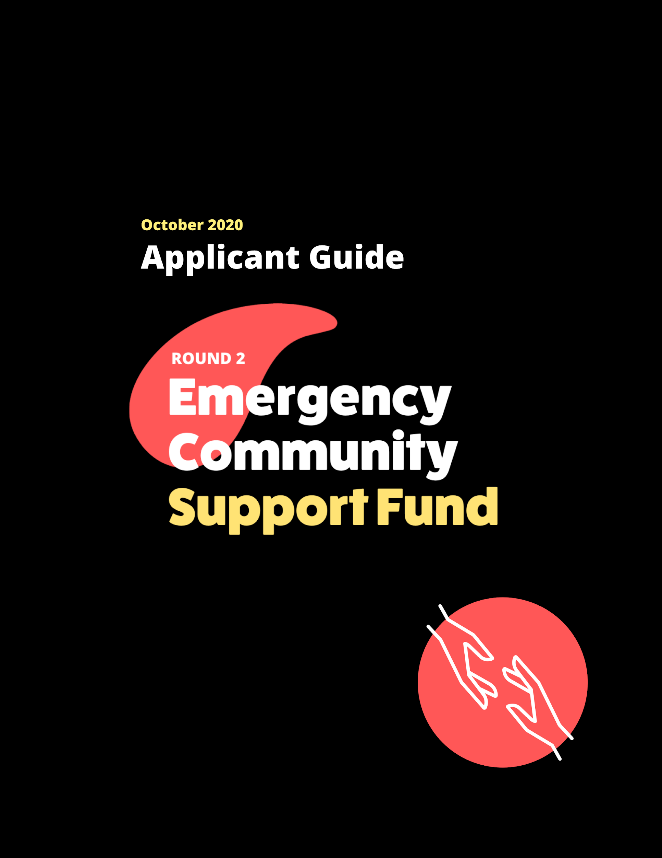

Applicant Guide: The Emergency Community Support Fund (ECSF)
The Emergency Community Support Fund (ECSF) is a $350 million investment made by the Government of Canada to support vulnerable populations as they manage the impacts of COVID-19.
The Government of Canada held back funds from the first round which was disbursed between May 19 and July 27, 2020. The remaining funding is now being made available to support communities continuing to address the impact of the pandemic.

The Government of Canada has partnered with national intermediaries,Community Foundations of Canada, the Canadian Red Cross, and United Way Centraide Canada, to deliver the ECSF. While intermediaries are managing their respective funding streams separately, they are coordinating to ensure funding flows swiftly to organizations. See the infographic to learn more about what each intermediary is funding and where you can apply.

This document intends to support qualified donee applicants interested in applying to Community Foundations of Canada’s ECSF program.

Which partner should I apply to? 2
What is a community foundation? 2
Eligible organizations 2
Eligible projects 3
Eligible expenses 5
Ineligible Projects and expenditures 5
Are applicants required to submit a project budget? 6
Timeline 6
What are the grant amounts through the ECSF? 7
When can I expect to receive results? 7
How to apply 7
Can applicants who applied in round one reapply in round two? 8
Where should national/provincial qualified donees apply? 8

Which partner should I apply to?

- Community Foundations of Canada - Local community foundations across Canada will accept and assess applications from qualified donees through a centralized national portal.

- United Way Centraide Canada - Local United Way Centraide members will accept and assess grant applications from charities through local portals. In some cases, local United Way Centraide members may also support non-profit organizations through an appropriate trustee relationship with a qualified donee.

- Canadian Red Cross - National granting program for eligible non-profit organizations across Canada. As well, the Red Cross Preventing Disease Transmission Training and Equipment Program is open for all eligible charities, qualified donees and non-profit organizations.
See this infographic for further information.

What is a community foundation?
Community foundations are philanthropic organizations that direct grants, leadership and other investments toward community initiatives. Across the country more than 90% of communities have access to a community foundation - from our largest cities to our smallest towns. The ECSF will be managed at the local community level by a network of community foundations, located coast to coast to coast.

Visit our website to find the community foundation nearest you.

Eligible organizations
The ECSF run by CFC will support qualified donees in running projects at the community level that serve vulnerable populations that have been especially affected by COVID-19. Eligible projects include ongoing programs that meet the eligibility criteria outlined in this document. Qualified donees should be in touch with their local community foundation to learn more about available grant sizes.

Applicants will be required to share how their project assists vulnerable populations, the populations they serve, and the impact of the project on the community.

Qualified donees include:
- Registered charities
- Registered Canadian amateur athletic associations
- Low-cost housing corporations for the aged
- Registered Municipalities or their housing, cultural and recreational agencies
- First Nations and other registered municipal or public bodies performing a function of government in Canada

Those ineligible to apply include:
- Individuals
- the Government of Canada (federal government);
- provincial and territorial governments (this does not include provincial crown corporations);
- the Crown; and
- the United Nations.
Qualified donees must be registered on the CRA’s list of qualified donees. Applicants will be required to provide their CRA charitable registration number (where available) and the CRA qualified donee weblink to authenticate their qualified donee status.

Eligible projects
The ESCF will provide immediate financial support for projects that are serving vulnerable populations as they manage the impacts of COVID-19. Qualified donees may apply for more than one grant at the local level, as long as each application describes a distinct project and there is no duplication of eligible costs across multiple projects. Applicants to the National/Provincial Stream can only submit one application.

Specifically, eligible projects will:

- Clearly address a pressing social inclusion or well-being need caused by COVID-19;
- Serve one or more vulnerable groups (defined below);
- Be carried out in a short timeframe - between April 1, 2020 and March 31, 2021 - and with a reasonable budget

Examples of eligible projects where vulnerable populations impacted by COVID-19 include:

- Creation of a digital health platform to continue mental health and addictions recovery programming
- Development and delivery of a virtual mental health program for caregivers
- Purchase of food kits for marginalized families experiencing interrupted support services
- Addition of meal service staff at a women’s shelter to meet public health guidelines
- Food purchase assistance for members living on-reserve, where supplies and delivery are interrupted
- Purchase of a freezer by a food bank to accommodate rise in food orders
- Technology purchase and service enabling seniors in-residence to connect with their families virtually
- Increased staffing and supplies at a shelter for women and children fleeing violence
- Preparing and delivering food for persons with disabilities
- Remote arts programming for vulnerable youth
- Procurement and delivery of educational materials to Aboriginal Friendship Centre families
- Development of online social skills curriculum for individuals with special needs, replacing in-person programming
- Deployment of a social worker to provide Deaf community with information on COVID-19 and support to navigate impact relief services

Vulnerable populations include:

Children, Youth or Elderly
- Children and youth (ages 0-29)
- Youth ageing out of care
- Seniors and Elders (in and not in care)

Vulnerable Workers
- Caregivers
- Workers who are vulnerable (essential, temporary foreign, those in the informal labour market)

Populations Requiring Specific Care or Supports
- People experiencing homelessness
- People struggling with addiction
- People living with mental illness
- People with low-income or living in poverty
- Persons with disabilities
- People experiencing domestic or gender-based violence
- People living in group homes or supportive living (under the age of 55)
- Prison populations (detained and incarcerated)
- Veterans
- Students (postsecondary)

Marginalized Communities in Canada
- Official Language Minority Communities (OLMCs)
- Women and girls
- Members of LGBTQ2s+ communities
- Newcomers (Permanent and temporary residents including immigrants and refugees)
- Racialized people (Arab, Black, Chinese, Filipino, Japanese, Korean, Latin American, South Asian, Southeast Asian, West Asian, Other racialized groups)
- Indigenous people (First Nations, Métis, Inuit)

The ECSF will prioritize applications that value and embody the concept "nothing about us, without us" within their organizational structure and programming. This includes looking at how individuals representative of the population(s) you're seeking to serve, will be involved in the decision making and delivery of your project.

Eligible expenses

All budget items must be project-related and must be incurred between April 1, 2020 and March 31, 2021. Eligible expenditures will vary depending on the project. The list below are examples of possible expenditures.
- Wages and employment-related costs for existing or additional staff;
- Fees for professional service;
- Disability supports for staff of the Grant Recipient;
- Materials and supplies;
- Printing and communication;
- Travel costs;
- Utilities;
- Insurance;
- Rental of premises;
- Lease, purchase and maintenance of equipment;
- Performance monitoring and reporting costs;
- Data collection;
- Knowledge development activities; and
- Other administrative costs associated with the project.

Ineligible Projects and expenditures

Ineligible projects include:
- Projects designed to provide financial stabilization, recovery and/or resilience of an organization’s general operations,
- Projects that are designed for fundraising purposes,
- Profit-generating projects or activities,
- Research projects where findings and tangible applications do not directly benefit vulnerable populations impacted by COVID-19,
- Any activity taking place outside of Canada,
- Project costs that have received funding through another ECSF intermediary (Canadian Red Cross or United Way Centraide Canada). A project can receive funding from more than one ECSF intermediary as long as there is no duplication of funding for the same project costs.

The following expenditures are ineligible, and will not be supported by the ECSF:
- Purchase of real property (land or building)
- Expenses incurred prior to April 1, 2020
- Expenses incurred after March 31, 2021
- Any expenses that are covered by another funding source (including the Government of Canada, Canadian Red Cross and United Way Centraide Canada or their local affiliates). Projects may receive funding from other sources, but those funds may not cover the same expenses as this grant.

Are applicants required to submit a project budget?

Applicants are required to submit a budget to identify eligible project expenses. Please ensure that your budget accounts for the full amount of the grant that you have requested.

- All budget items must be project-related and must be incurred during the grant period (April 1, 2020 - March 31, 2021).
- Eligible expenditures include: wages and benefits, professional fees, travel and accommodations, materials and supplies, printing and communication, equipment rental/lease/maintenance, administration costs, and disability support for staff.
- Ineligible expenditures include: purchase of real property (land or buildings).
- Specific eligible costs and expenses funded by an ECSF grant cannot receive funding from other sources.
- Funds received through this program cannot be used to generate a profit or an income in excess of project expenses for the recipient organization.
- The downloadable budget template can be found within your application

Timeline
The community foundation network is accepting applications beginning on October 5, 2020. Applications must be submitted before October 30, 2020 at 11:59 PM PST for activities occurring between April 1, 2020 and March 31, 2021. Please consult the list of participating community foundations to verify whether your community foundation is accepting applications.

If your community foundation is not participating, you can still apply by selecting ‘Community Foundations of Canada’.

What are the grant amounts through the ECSF?
The grant maximum is $75,000, except for the National/Provincial Stream where the grant maximum is $200,000.

Community Foundations may also set their own limits lower than indicated here, please check with your local Community Foundation. There is no minimum grant amount.

When can I expect to receive results?
Applications must be submitted by October 30, 2020 at 11:59 PM PST. Applicants will receive a decision no later than December 15, 2020 at 11:59 PM PST.

How to apply
Most applicants will apply to their local community foundation.
Please use our search tool on our website to find a community foundation near you.

If you are unsure, please contact a community foundation to verify whether they serve the area where your project is being delivered. Applications made to incorrect community foundations may experience review delays while they are re-routed to the correct community foundation.

If you do not have a local community foundation serving the project location you will select Community Foundations of Canada as your local community foundation.

If you are a national charity please refer to our question on national/provincial qualified donees and consult this infographic.

When you are ready to apply, please visit the Application Portal. Please review this video for instructions and help with submitting your application.

If you have additional questions please contact CFC at covid19@communityfoundations.ca.

Can applicants who applied in round one reapply in round two?

Applicants who received ECSF funding in Round 1 can submit an application in Round 2 for project costs which were not funded in Round 1. Applicants cannot receive funding twice for the same project costs. Applicants must submit a budget to identify new eligible costs.

Applicants who were declined in Round 1 of ECSF can submit an application for the same or different project costs, as long as funding for the project costs was not provided by any of the ECSF funding intermediaries in Round 1.

Applicants whose applications were not considered by a community foundation in Round 1 due to a high level of demand are considered oversubscribed applications. Any work started on oversubscribed applications has been saved in the portal. Applicants can reapply using their Round 1 application. Please note however, that a few additional questions and other information will be required as part of Round 2, should you wish to resubmit an application that did not receive funding in round one. Declined applications have not been saved in the portal.

Where should national/provincial qualified donees apply?
National/provincial organizations should apply to CFC’s National/Provincial stream OR their local community foundation depending on how their organization is structured. The National/Provincial Stream, like all ECSF funding streams, is highly competitive.

National or provincial organizations who are registered with a singular CRA number must apply to CFC’s National/Provincial Stream. Grant amounts in this stream are up to $200,000. This includes organizations with or without local chapters/regional branches. The CFC National/Provincial Stream is for organizations whose mission and mandate is to serve one or more provinces or has a nation-wide coverage. Organizations can only submit one application to CFC's National/Provincial stream.
Here are examples where organizations would apply to the National/Provincial Stream:
- Example A: Our head office is located in Montreal, QC. We deliver programming across Canada, but primarily in Quebec and Manitoba. We offer a mix of tailored programming specific to the general community and classroom.
- Example B: Our head office is located in Regina, SK. We have a national mandate to serve any Canadian suffering from mental health issues. Pre-COVID19 we had a chapter based model. In a COVID-19 context, we are expanding our traditional programming to locally-led, yet virtual programming.
- Example C: Our head office is located in Calgary, AB. We have provincial ambassadors in several communities who are providing a mix of in-person and online support services.
- Example D: Our national head office is located in Toronto, ON and we have two provincial offices (Vancouver & Calgary). We are now expanding our programming entirely online, recruiting volunteers to help serve more children across Canada.

National/provincial organizations with local members/chapters/regional branches who each have a separate CRA number (e.g federated/association/membership model etc). If the national office is delivering a project they must apply to the National/Provincial stream. If the national organization members have a province-wide mission and mandate, they must apply to the National/Provincial Stream. Grant amounts in the National/Provincial Stream are up to $200,000. If their local chapters are delivering separate and distinct projects, they must apply to their local community foundation. Each organization, with a unique CRA number, can only submit one application to CFC's National/Provincial stream.
- Example A: Our offices are in Vancouver. We have a head office in Ottawa but we have a separate CRA number and we provide services to the entire province of BC. We’ll apply to the National/Provincial Stream
- Example B: We are the national head office located in Ottawa for a group of local community organizations across the county. Our national head office will apply to the National/Provincial Stream and our local community organization partners can apply to local community foundations..
- Example C: We are a community organization in Winnipeg with our own CRA number but we are part of a broader national organization. We’ll apply to our local community foundation.

How to apply to the National/Provincial Stream: In the Application Portal, when selecting the local community foundation where a project will be delivered, please choose ‘Community Foundations of Canada’ from the drop-down menu and subsequently select ‘National/Provincial Stream’. Organizations that apply to the National/Provincial Stream are ineligible from submitting applications to local community foundations.
Regional organizations whose mission and mandates service a portion of a province(s) must apply to their local community foundation(s) for grants up to $75,000. For example, if an organization’s mission and mandate services solely Southern Alberta or Northern BC, then they would apply to the local community foundations in the communities where it operates.
If you have questions, please contact covid19@communityfoundations.ca.

